
Year 9

Test 2 Pathway 2

Surface Area

Resources allowed: Calculator and 1 x A4 page one side

Name: ______________________ Class: ______ Time: 45 minutes Total Marks: 40

- (12 marks)
Calculate the area of the following shapes correct to two decimal places

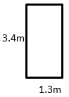 | 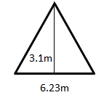 |  | 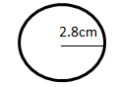
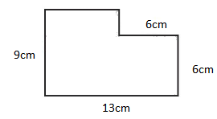 |  | 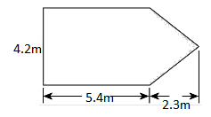

- (3 marks)
An area of lawn in a backyard is made up of a rectangle measuring 12m by 13m. In the centre of the lawn area there is a paved area in the shape of a circle with a radius of 2m. Find the total area of lawn correct to two decimal places.
(Hint: Draw a diagram)

- (2 marks)
Draw the net of the following objects
- Rectangular prism | - Cylinder

- ( 12marks)
Calculate the surface area of the following
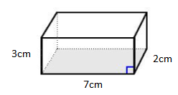 | 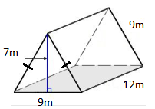
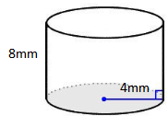 | 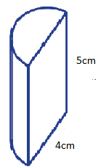

- (5 marks)
The outside of an old rectangular jewellery box is being covered in material to make it look like new again. How much material is required to cover the box if the box has dimensions of 10cm, 13cm and 5cm.

Extension:
- (2 marks)
Mathematicians like to be incredibly accurate with their calculations. Find the answer to Question 4 part c) and d) in exact form.

- (4 marks)
A log with a diameter of 80cm is 4m in length. Its hollow centre is 30cm in diameter. Find the surface area of the log in $cm^{2}$, including the ends and the inside correct to 2 decimal places.

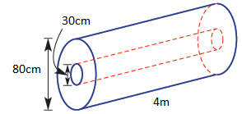

End Test

